WORLD MAP
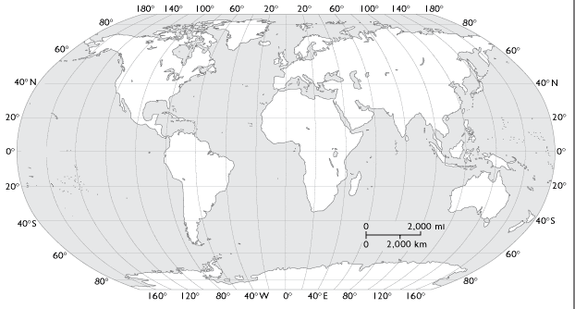
The first three things to look for on a map are: ________________________
________________________
________________________
Longitude and Latitude:
Find the following coordinates and mark on the map the appropriate letter, mark the spot on the map with appropriate letter:
A – 40N / 30 W Location Name: _______________________
B – 20N / 120W Location Name: _______________________
C – 60N / 150W Location Name: _______________________
D – 20N / 30E Location Name: _______________________
E – 30N / 45E Location Name: _______________________
F – 0 / 60W Location Name: _______________________
G – 10S / 120W Location Name: _______________________
H – 30S / 30E Location Name: _______________________
I – 10S / 135E Location Name: _______________________
J – 45N / 120E Location Name: _______________________

